**Sample Enum**

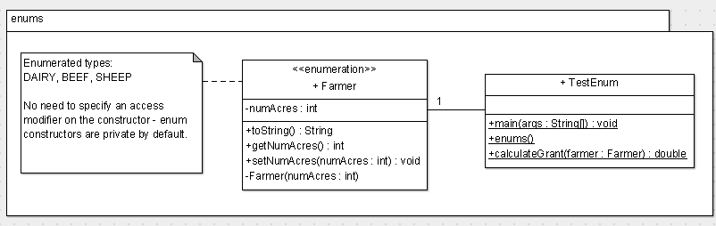

**Instructions**:

* 1. Create an enumeration named *Farmer*. This enumeration should contain constants that represent three types of farmers: DAIRY, BEEF and SHEEP (in that order). Farmers have the following default number of acres: Dairy farmers have 200 acres; Beef farmers have 150 acres and Sheep farmers have 160 acres. Obviously this can change i.e. provide for this situation. The enumeration also has a *toString()* method that returns the farmer type and the number of acres owned (see Sample Output).
  2. The method *calculateGrant(FarmerType)* calculates and returns the overall grant payment for the farmer according to the following logic:
     + If a beef farmer:
       1. If a small farmer (number of acres owned is < 200) then the grant is 200.0 * the number of acres owned; otherwise, you are considered a big farmer and the grant is 50.0 * the number of acres owned
     + If a dairy farmer:
       1. If a small farmer (number of acres owned is < 200) then the grant is 300.0 * the number of acres owned; otherwise, you are considered a big farmer and the grant is 80.0 * the number of acres owned
     + If a sheep farmer:
       1. If a small farmer (number of acres owned is < 200) then the grant is 150.0 * the number of acres owned; otherwise, you are considered a big farmer and the grant is 40.0 * the number of acres owned
  3. In *enums()*, declare a beef farmer variable/reference named *john*. John has bought some land and now owns 500 acres.   
     Using *calculateGrant(),* calculate and output *john*’s grant payment. Also, invoke the *toString()* method for *john*.